

**Software Requirements Specification (SRS)**

**School Management System**

**Version 1.0**

**Prepared by: W. M. L. D. Weerasinghe**

**Date: [2024/ 03/ 07]**

**Approved by: [Mr. Thanesh Kumar/ Lecturer]**

Contents

1. Introduction 4

1.1 Purpose 4

1.2 Scope 4

1.3 Definitions, Acronyms, and Abbreviations 4

1.4 References 4

2. Overall Description 5

2.1 Product Perspective 5

2.2 Product Functions 5

2.3 User Characteristics 6

2.4 Constraints 6

3. Specific Requirements 7

3.1 Functional Requirements 7

3.2 Non-Functional Requirements 7

3.3 External Interface Requirements 8

4. SDLC Timeline 8

5. Diagrams 9

5.1 ER Diagram 9

5.2 DFD Level 0 10

5.3 DFD Level 1 11

5.4 Use Case Diagram 12

6. User Interfaces 13

6.1 Loading 13

6.2 Login 14

6.3 Home 15

6.4 Current Principle 16

6.5 Edit Details in principle 17

6.6 Principle Table 18

6.7 teachers table 19

6.8 Teachers Edit 20

6.9 Student Table 21

6.10 Student Edit 22

6.11 Admin Registration 23

7. Appendices 23

8. Final Notes 24

# 1. Introduction

## 1.1 Purpose

This document defines the functional and non-functional requirements for the School Management System (SMS), a desktop-based application designed to streamline student records, teacher data and principles data management for school administrators.

## 1.2 Scope

The School Management System (SMS) is a standalone desktop application that enables administrators to:

* Manage student enrollment, and grades
* Maintain teacher records and schedules
* Generate reports
* Ensure secure access via role-based authentication (admin-only)

**Out of Scope:**

* Mobile or web access
* Parent/student/teacher self-service portals

## 1.3 Definitions, Acronyms, and Abbreviations

**Term Definition**

* SMS School Management System
* GUI Graphical User Interface
* DBMS Database Management System
* JRE Java Runtime Environment

## 1.4 References

* IEEE Standard for Software Requirements Specifications (IEEE Std 830-1998)
* Oracle Java SE Documentation
* MySQL Official Documentation

# 2. Overall Description

## 2.1 Product Perspective

**Type:**

* Standalone desktop application

**Tech Stack:**

* Frontend: Java Swing
* Backend: Java
* Database: MySQL
* IDE: NetBeans

**Deployment:**

* Windows & Linux

## 2.2 Product Functions

|  |  |
| --- | --- |
| Feature | Description |
| User Authentication | Secure login for administrators |
| Student Management | Add, update, delete, search student records |
| Teacher Management | Register, update, manage teacher data |
| Grade Management | Assign, store, and retrieve student grades |
| Reports & Logs | Export students/teachers/principles reports |

## 2.3 User Characteristics

**Primary Users:**

* School administrators

**Technical Skill:**

* Basic to moderate computer proficiency

**Access Control:**

* No access for students, teachers, or parents

## 2.4 Constraints

**Platform:**

* Windows & Linux only

**Database:**

* MySQL

**Scalability:**

* Single-school deployment (v1.0)

**Security:**

* Role-based access (admin-only)

# 3. Specific Requirements

## 3.1 Functional Requirements

|  |  |  |
| --- | --- | --- |
| ID | Requirement | Priority |
| FR1 | Secure admin login system | High |
| FR2 | CRUD operations for student records | High |
| FR3 | Attendance tracking (daily/monthly) | Medium |
| FR4 | Automated report generation (PDF/Excel) | Medium |

## 3.2 Non-Functional Requirements

|  |  |
| --- | --- |
| ID | Requirement |
| NFR1 | Supports 500+ concurrent users |
| NFR2 | Response time < 2 sec for key operations |
| NFR3 | Data encrypted in MySQL |

## 3.3 External Interface Requirements

**GUI:**

* Java Swing

**Database:**

* MySQL 8.0+

**Printing:**

* JasperReports for PDF generation

# 4. SDLC Timeline

|  |  |  |
| --- | --- | --- |
| Phase | Duration | Deliverables |
| Requirement Analysis | **2 Weeks** | **SRS Document** |
| System Design | **3 Weeks** | **ER Diagrams, UI Mockups** |
| Implementation | **6 Weeks** | **Core System Development** |
| Testing | **3 Weeks** | **Unit & Integration Tests** |
| Deployment | **2 Weeks** | **Test Environment Setup** |
| Maintenance | **Ongoing** | **Bug Fixes & Updates** |

# 5. Diagrams

## 5.1 ER Diagram

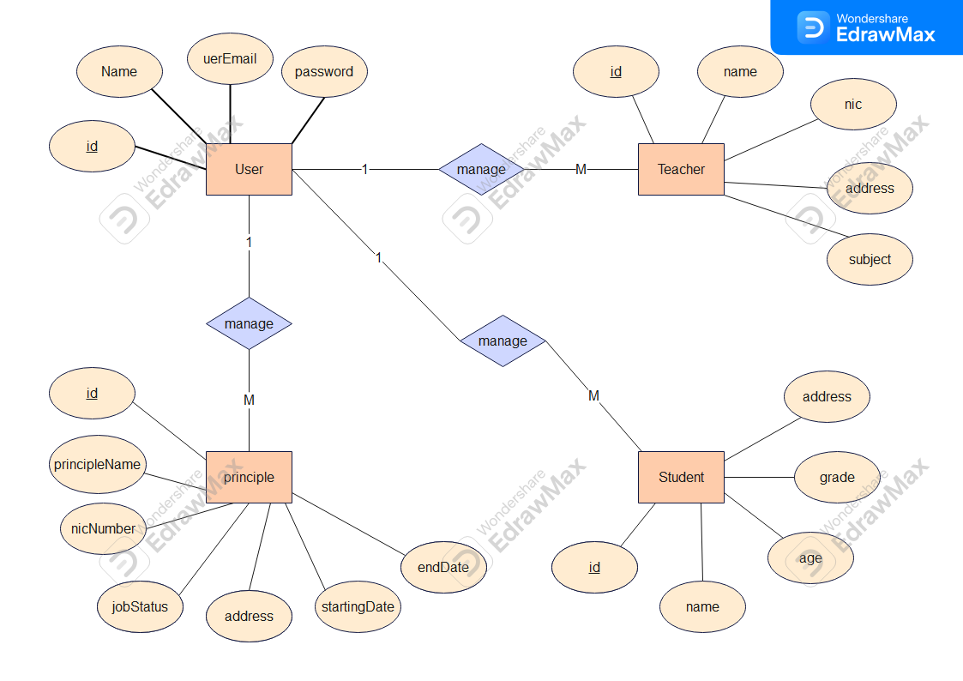

## 5.2 DFD Level 0

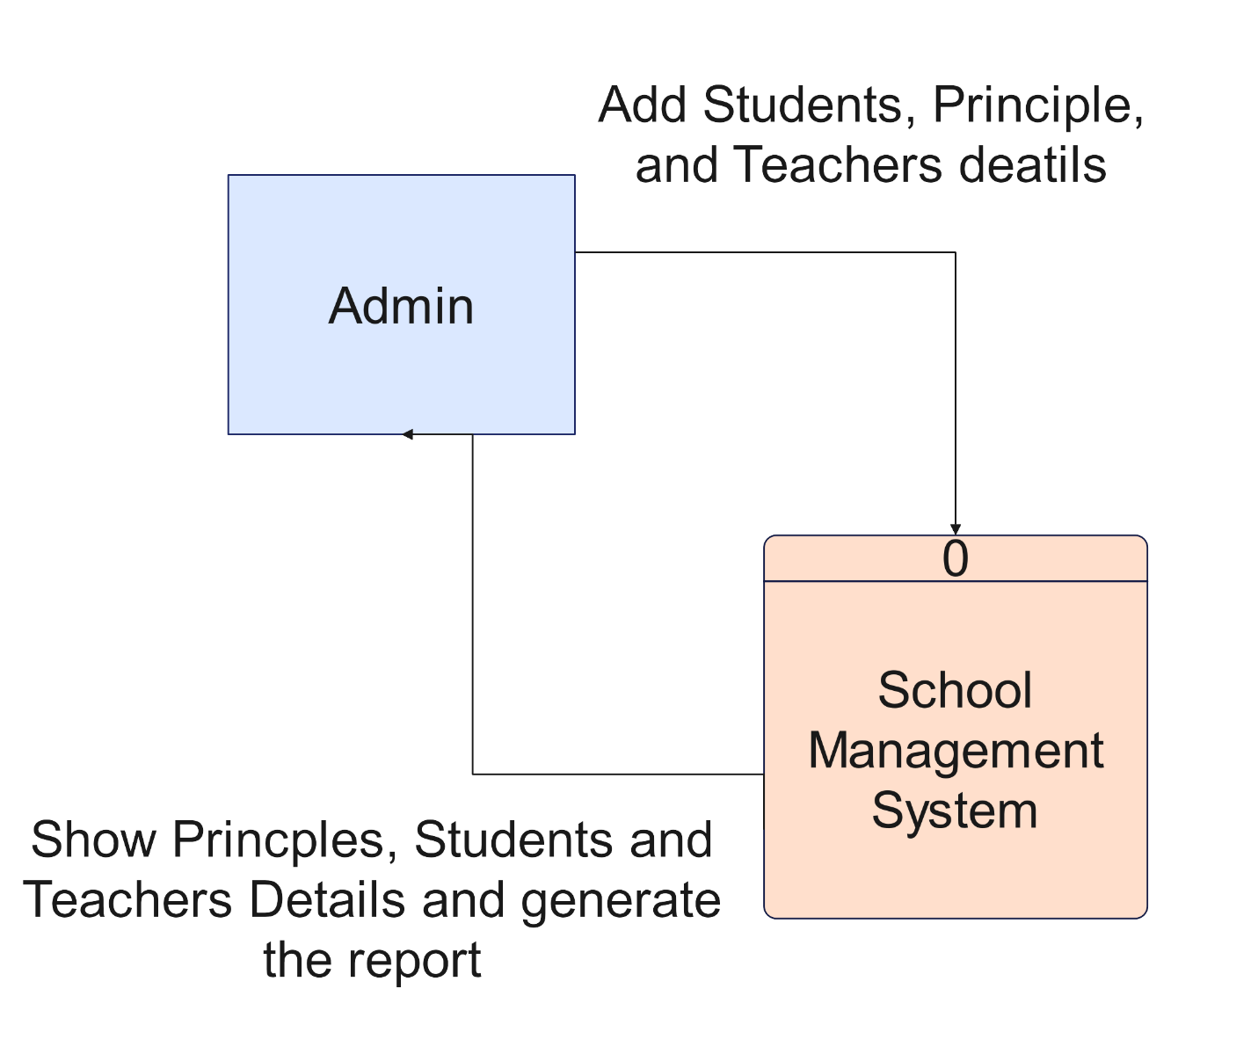

## 5.3 DFD Level 1

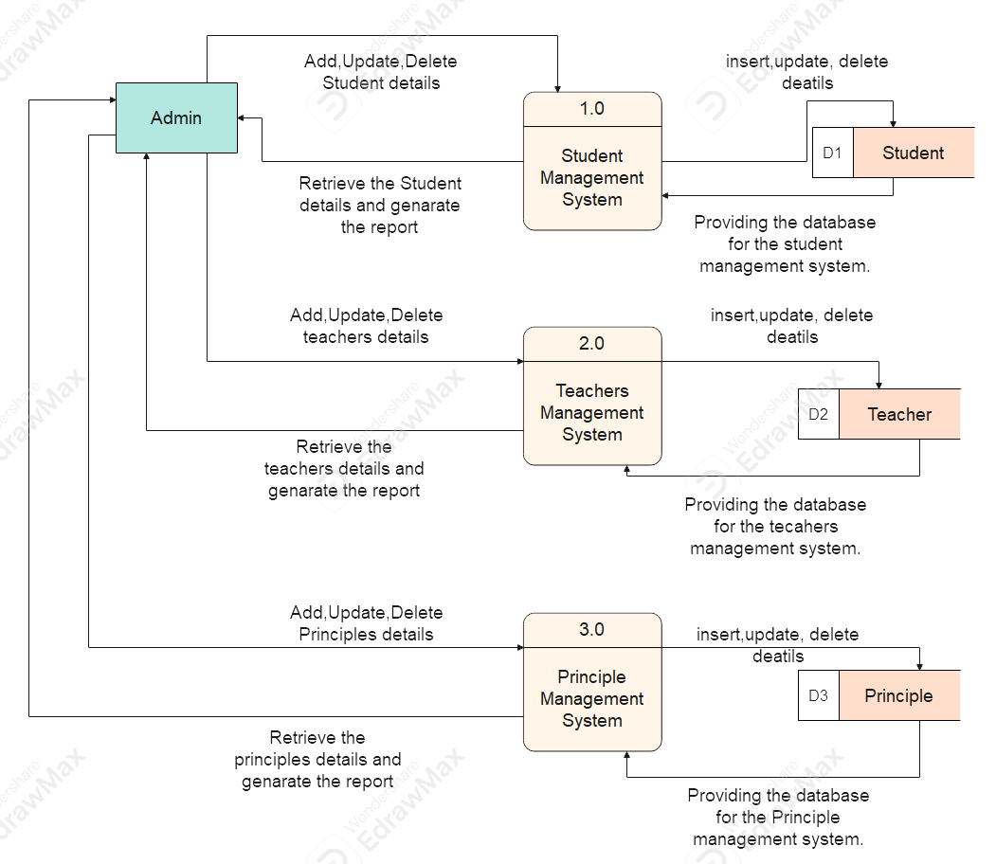

## 5.4 Use Case Diagram

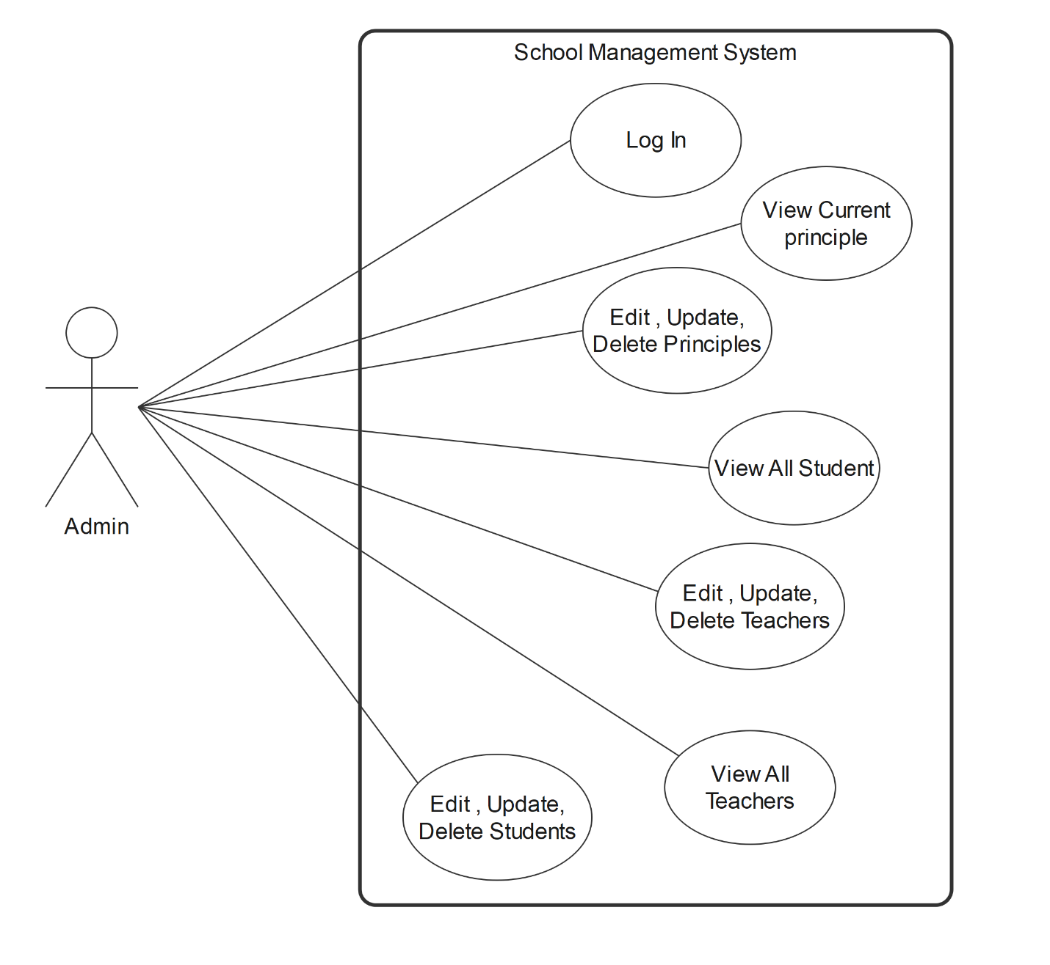

# 6. User Interfaces

## 6.1 Loading

## 6.2 Login

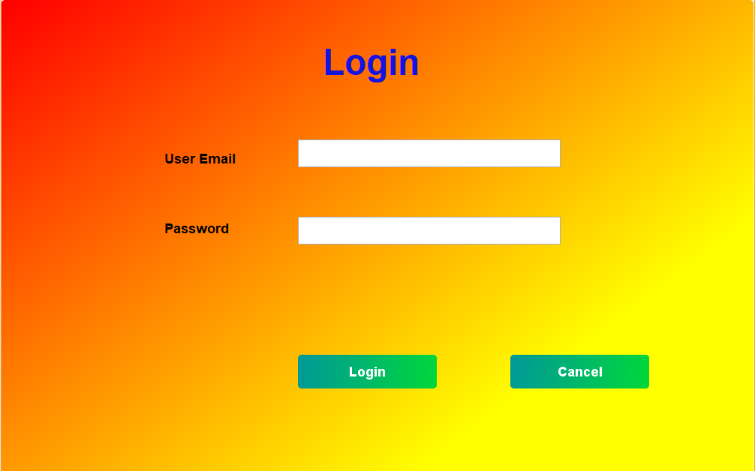

## 6.3 Home

## 6.4 Current Principle

## 6.5 Edit Details in principle

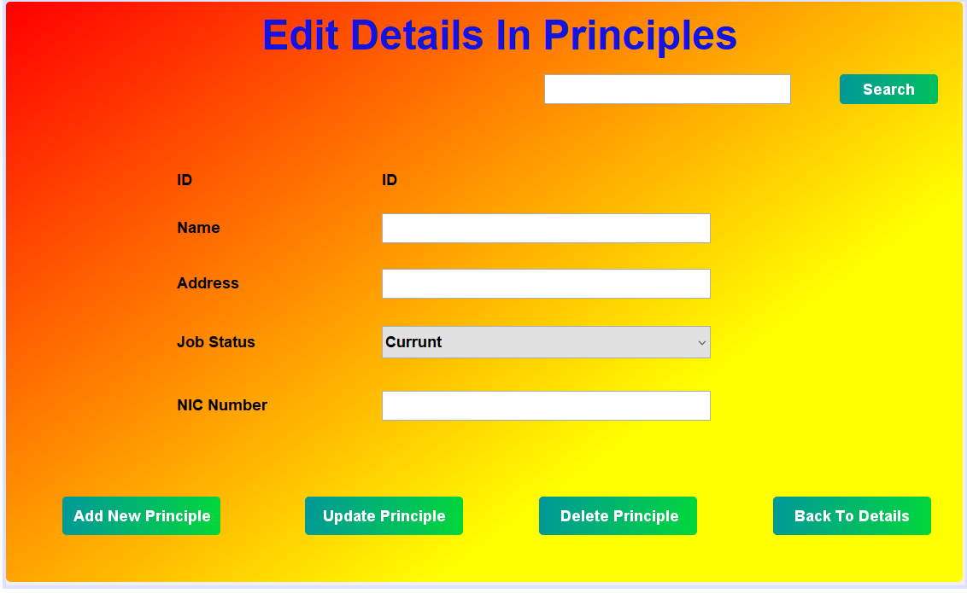

## 6.6 Principle Table

## 6.7 teachers table

## 6.8 Teachers Edit

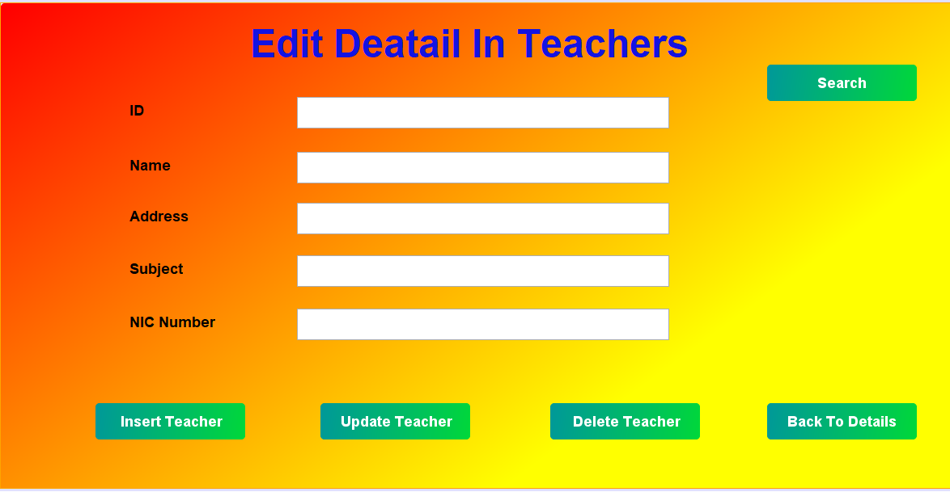

## 6.9 Student Table

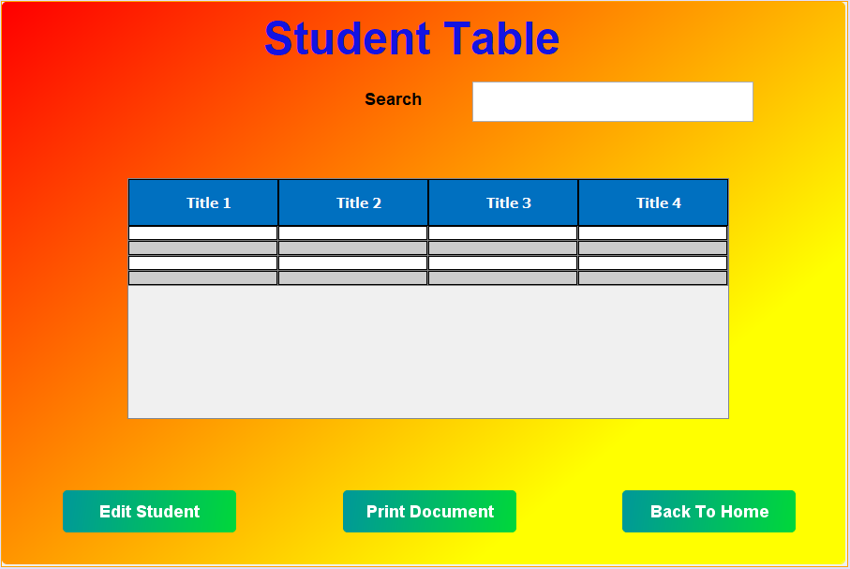

## 6.10 Student Edit

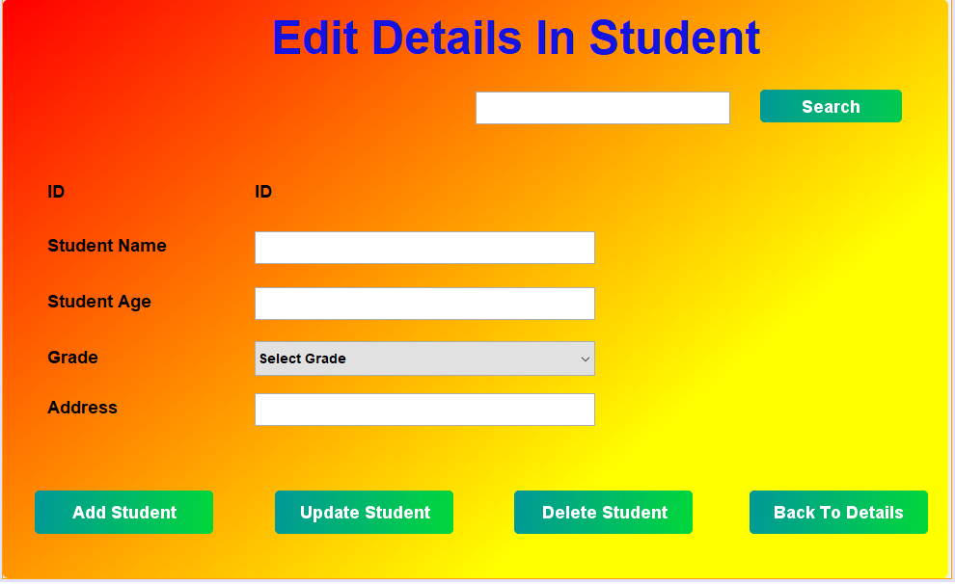

## 6.11 Admin Registration

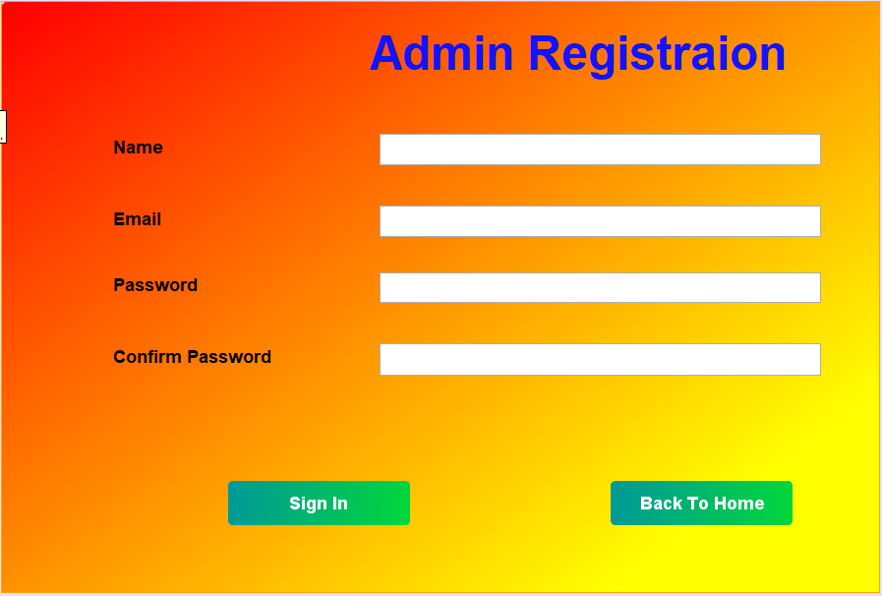

# 7. Appendices

* Glossary
* Abbreviations
* Version History

# 8. Final Notes

**This document serves as the single source of truth for the School Management System development. Any modifications must be reviewed and version-controlled.**

**Prepared by:**

**[W. M. L. D. Weerasinghe]**

**[Developer]**

**[0742449003]**